Year 3 Science – Plants and Light
Ideas to Support your child with science learning
Water transportation in plants
All plants need water to survive and water is transported around all parts of a plant. But how is water brought to the leaves? The roots take it up by a process called ‘transpiration’.
Experiment to check how water is transported (moved) through plants.
You can write a prediction, what you did, what happened and if you were right.
Half-fill 3 plastic bottles with water and food colouring - a different food colouring in each bottle and plenty of it. Arrange white flower stems (carnations or tree blossom if possible) in 2 of the bottles and leafy celery stems in the other. Although the flowers and stems do not have roots, they should still take up water and the dye will help to see how it moves up the stems. Place the bottles in a safe place where children can see them over the coming days. What other plants do they think this might work with? Why?
https://www.bbc.co.uk/teach/class-clips-video/science-ks1-ks2-ivys-plant-workshop-how-does-water-get-from-the-roots-to-the-leaves/zdtfjhv
You can try this too. Water is transported around plants to keep them healthy and give them the nutrients they need. In leaves, the veins transport the water. Watch this video and replicate it to create leaf skeletons, which show each individual vein!
https://www.youtube.com/watch?v=yW-6H-aP5ys
Shadows
Discover how shadows are made and investigate how changing the position of an object or the material it is made from can affect the nature and shape of the shadow. Create a shadow puppets show.
Task 1 - Guess my shadow
Take turns to select an object to cast a shadow in a beam of light and guess the object from its shadow. Children could experiment with showing an unusual angle of the object first before they gradually turn it to reveal its identity. This will help the children to understand that the shape of the shadow of an item can be very different depending on which aspect of it is facing the light source, e.g. a pencil can be seen as a dot if it is orientated with the end facing the light source.
Task 2 - Describe that shadow!
Use a torch or lamp and a selection of objects. Investigate different types of shadow. Introduce words opaque (blocks light), transparent (some light) and translucent (clear).
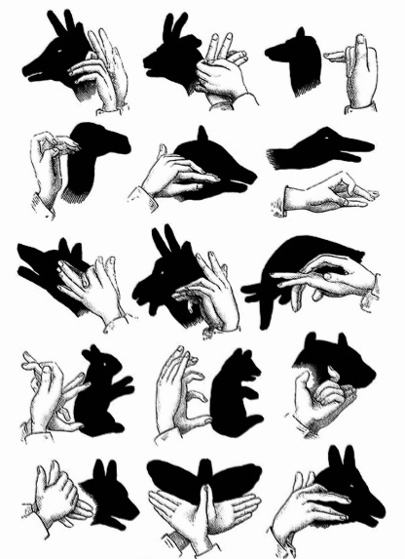
Task 3 - Hand Shadow Puppets
Take turns to shine a bright torch at a wall while someone makes shadows with their hands. Notice how the shape of the shadow changes as you move your hand into different shapes. Remember the shadow is made when your hand blocks the light. Try one or two of the hand shadow puppet ideas.

