Year 4 Geography- Climate change
Ideas to support your child with Geography learning

Project 1:
This climate change project can be done over 3 or 4 weeks.
Children could complete a project on climate change and create an information booklet to make other learners aware of what climate change is, the effects and impacts. Children could research using the internet and books first and then plan and create an information booklet. Below are some key questions which could be put as sub-headings for the booklet. Two sub-headings could be researched each week.

Sub- heading 1: What is climate change?
Sub- heading 2: What causes climate change?
Sub- heading 3: Why are sea levels rising?
Sub- heading 4: How will climate change effect the planet?
Sub- heading 5: How are people and wildlife being effected by climate change?
Sub- heading 6: Who is responsible for climate change?
Sub- heading 7: What can be done to help?

Project 2:
This project may take 1-2 weeks.
Make a poster which tells people what they can do to take action against climate change. This link gives ideas on what you can do to help. https://climatekids.nasa.gov/how-to-help/
- Research what action can be taken to help climate change.
- Think about how can you present your work so it is eye-catching, encouraging and persuasive?
- Create your poster on an A4 piece of paper or on a word document. You could change the text font, size and add pictures.
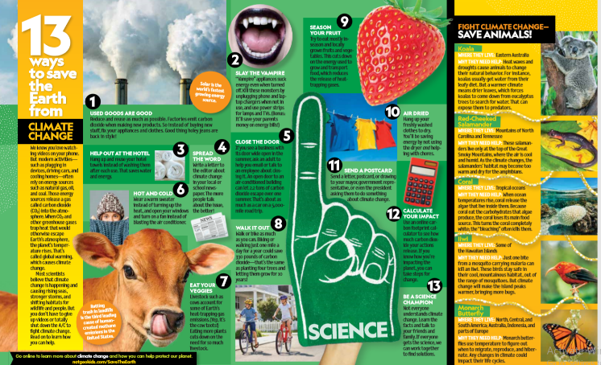
Here is an example which shows 13 ways to tackle climate change. It is presented clearly and teaches people different things they can do to help in an encouraging way.
https://www.climaterealityproject.org/sites/default/files/APR%2018%20NGK-Climate%20Change%20tips_0.pdf

